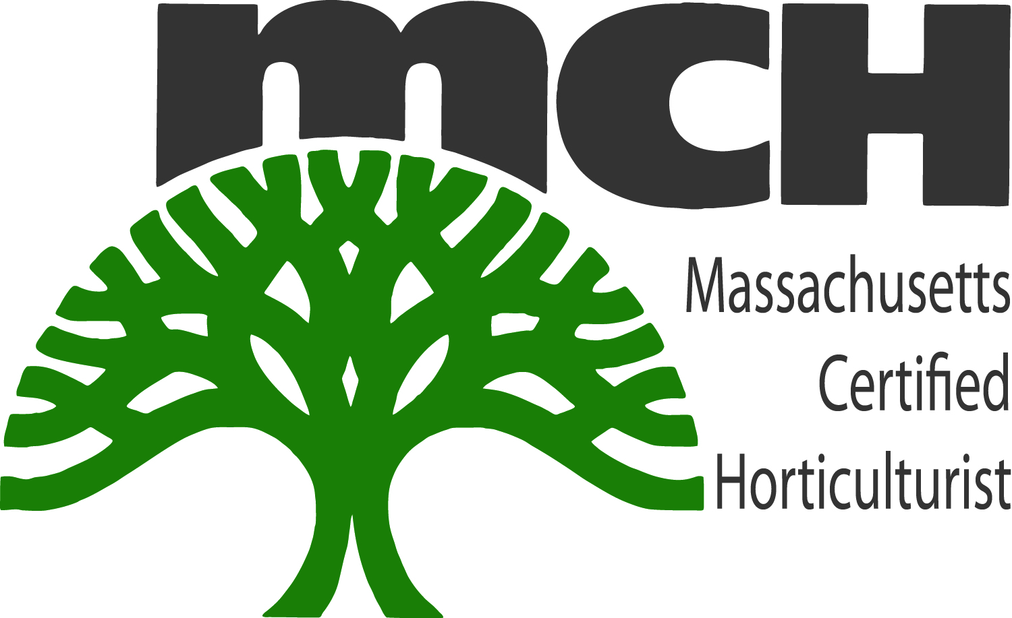

Massachusetts Certified Horticulturist (MCH) Emeritus Rules & Regulations

What is Emeritus status?
Emeritus status allows MCH’s to continue to use their designation(s) upon retirement from the profession without having to recertify on a yearly basis.

Who qualifies?
MCH individuals may request emeritus status if they are age 55 or above and/or are retiring from the green industry and maintained certification for at least ten (10) years prior to retirement. MCH’s who intend to continue working in the green industry (perhaps as a consultant or lecturer) are not considered retired and are not eligible for emeritus status.

How to:
To request emeritus status, please complete the form online (MCH Emeritus Request) outlining your intent to retire to the MNLA office, attention MCH Board, and include documentation of age (a copy of one’s driver’s license is sufficient). The letter (which may be e-mailed, mailed or faxed) must include your name, designation(s) and retirement date.

Requirement:
MCH individuals awarded emeritus statuses with the exception of hardship are expected to attend at least one (1) MNLA event each calendar year to maintain their certification.

Fee:
The processing fee is a one- time fee of $89.00 which will be contributed to the continuation of the MCH program.

Massachusetts Certified Horticulturist (MCH) Emeritus Request

Name:

Mailing address:
(Include full mailing address: street, city, state, zip code)

Phone:

Email:

Retirement Date:

Consideration Request:

Signature:

Please remit to: MCH Board, C/o MNLA, and P.O. Box 387, Conway, MA 01341
with the one-time fee of $89

